10 EPOCHS:

Epoch 1, total time 516.70
train_loss average 0.49492969412070054
-----------------------------------
Epoch 2, total time 522.74
train_loss average 0.452977930353238
-----------------------------------
Epoch 3, total time 518.68
train_loss average 0.43099871323658867
-----------------------------------
Epoch 4, total time 518.35
train_loss average 0.4166340211721567
-----------------------------------
Epoch 5, total time 516.69
train_loss average 0.4193898074902021
-----------------------------------
Epoch 6, total time 520.33
train_loss average 0.4004821147827002
-----------------------------------
Epoch 7, total time 517.60
train_loss average 0.38010539637162133
-----------------------------------
Epoch 8, total time 518.49
train_loss average 0.3442748808860779
-----------------------------------
Epoch 9, total time 524.59
train_loss average 0.294137330857607
-----------------------------------
Epoch 10, total time 518.25
train_loss average 0.27935262904717373

RESULTS:

Average test IoU: 0.7330
Average Dice: 0.8202

Training loss visual:
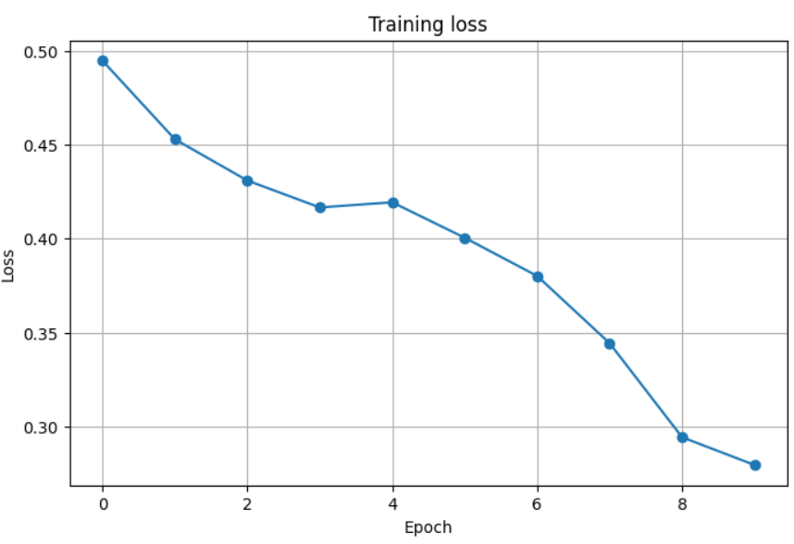

3 SETS OF EXAMPLE IMAGES:
